Assignment-12.2
Name : T.Harshitha
H.T No : 2303a51953
Batch : 22

Task Description -1 (Data Structures – Stack Implementation with
AI Assistance)
➢ Task: Use AI assistance to generate a Python program that
implements a Stack data structure.
Instructions:
Prompt AI to create a Stack class with the following methods:
➢ push(element)
➢ pop()
➢ peek()
➢ is_empty()
➢ Ensure proper error handling for stack underflow.
➢ Ask AI to include clear docstrings for each method.

Prompt :
Create a Python Stack class using a list. Include methods: push, pop, peek and is_empty. Add proper docstrings and it should handle edge cases and errors. Take input from user to demonstrate the functionality of the Stack class.

Code:

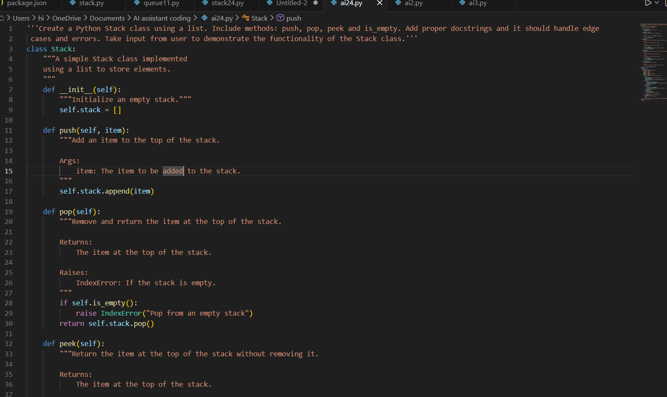

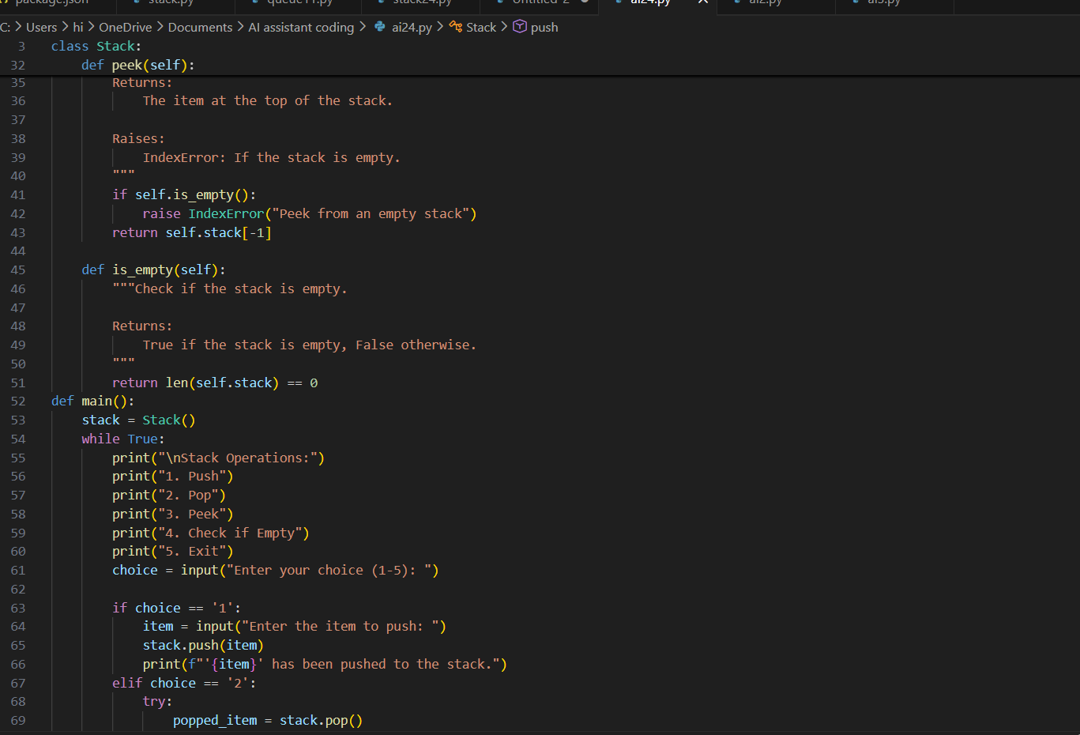
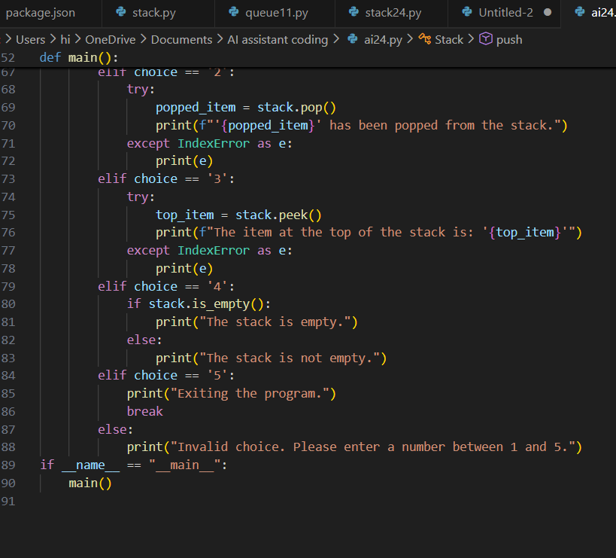

Output:
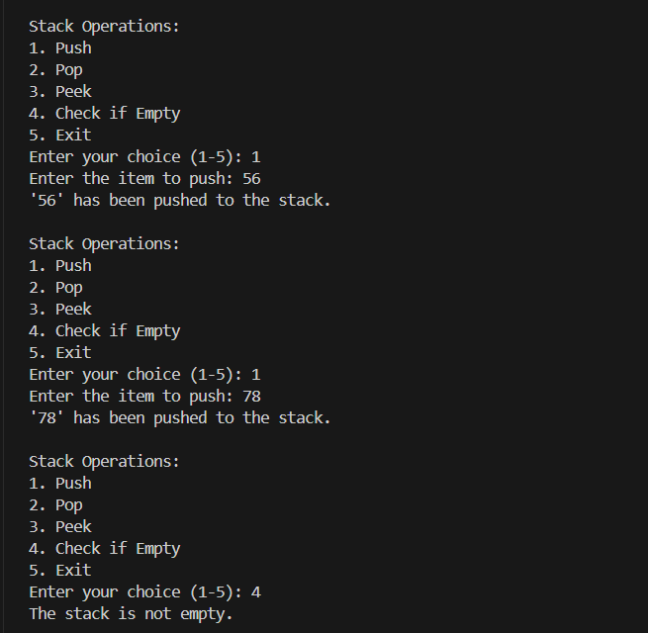

Explanation:
A Stack is used because it follows the Last In First Out (LIFO) principle, which is suitable for operations where the most recent element must be accessed first. Stacks allow efficient insertion and deletion operations using push and pop in constant time O(1). Other data structures like queues or lists do not strictly follow the LIFO order required for stack-based operations.

Task Description -2 (Algorithms – Linear vs Binary Search
Analysis)
➢ Task: Use AI to implement and compare Linear Search and
Binary Search algorithms in Python.
Instructions:
➢ Prompt AI to generate:
➢ linear_search(arr, target)
➢ binary_search(arr, target)
➢ Include docstrings explaining:
➢ Working principle
➢ Test both algorithms using different input sizes.

Prompt:
implement and compare Linear Search and Binary Search algorithms in Python.
linear_search(arr, target)
binary_search(arr, target)
Include docstrings explaining:Working principle
Test both algorithms using different input sizes.

Code:
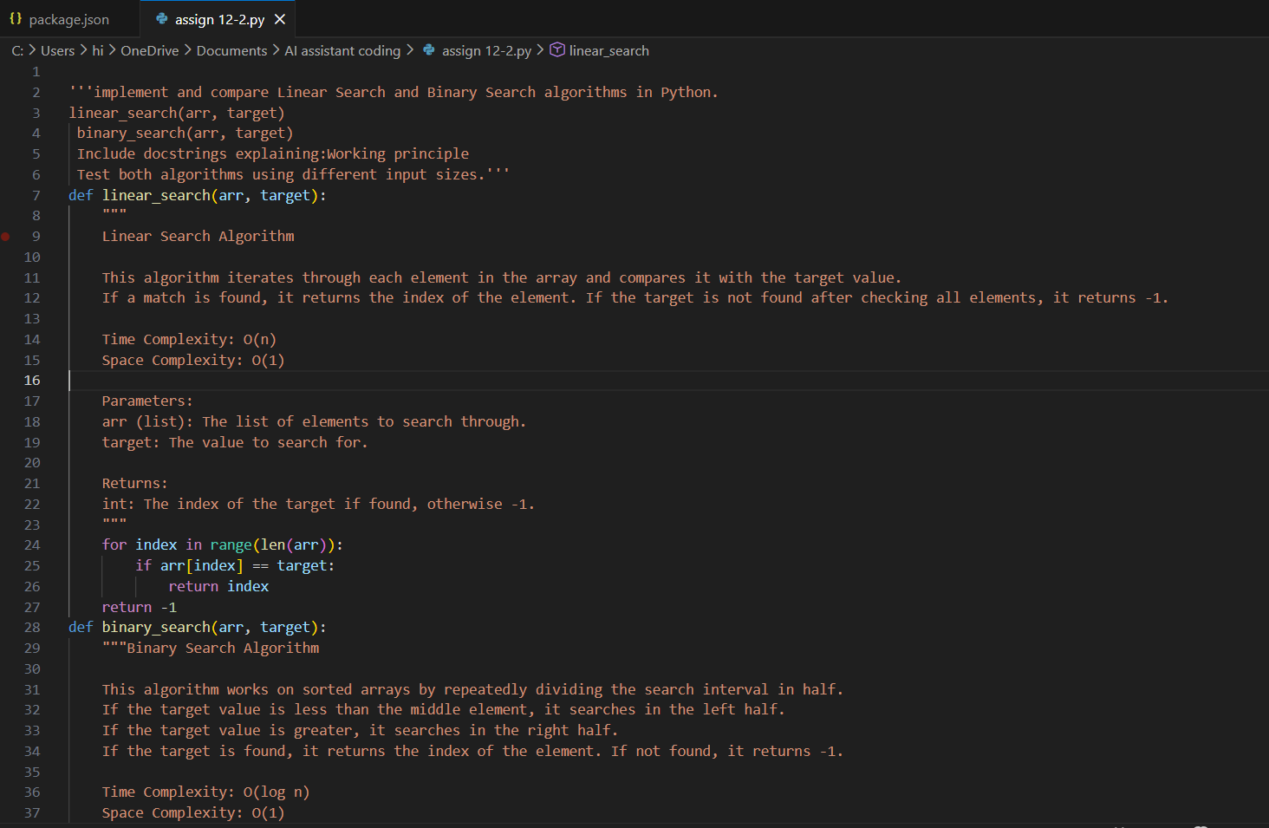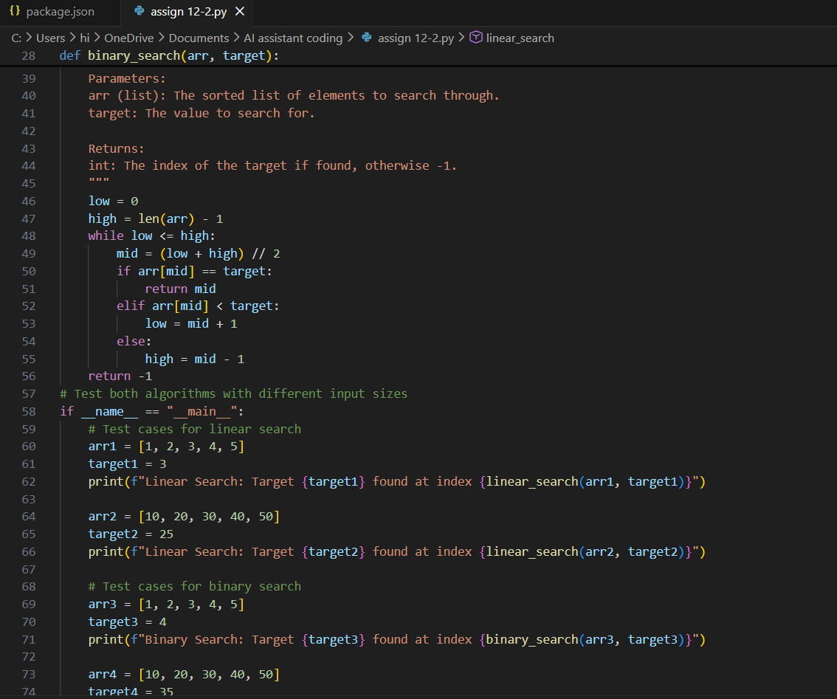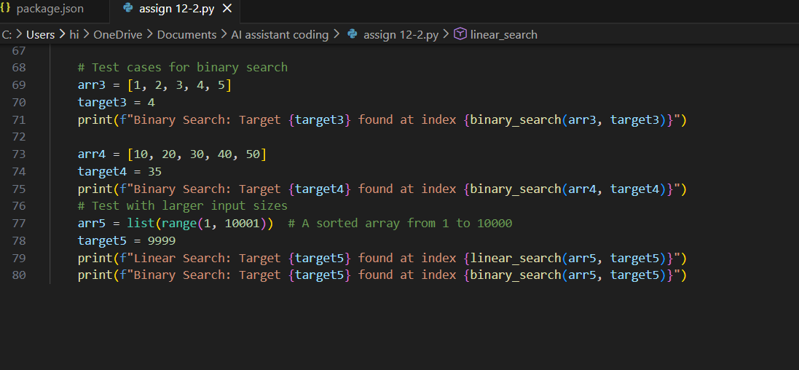

Output:
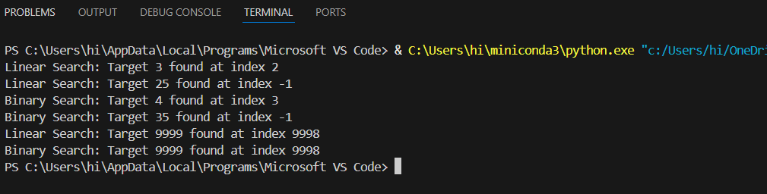

Explanation:
Linear Search and Binary Search use the Array/List data structure because it allows easy sequential and indexed access to elements. Binary Search specifically requires a sorted array to efficiently divide the search space. Other data structures like linked lists or trees are not suitable because they do not support efficient direct indexing required for Binary Search.

Task Description -3 (Test Driven Development – Simple Calculator
Function)
➢ Task:
Apply Test Driven Development (TDD) using AI assistance to
develop a calculator function.
Instructions:
➢ Prompt AI to first generate unit test cases for addition and
subtraction.
➢ Run the tests and observe failures.
➢ Ask AI to implement the calculator functions to pass all tests.
➢ Re-run the tests to confirm success.

Prompt:
Apply Test Driven Development (TDD) to develop a calculator function.
first generate unit test cases for addition and subtraction.
Run the tests and observe failures.
implement the calculator functions to pass all tests.
Re-run the tests to confirm success.

Code:
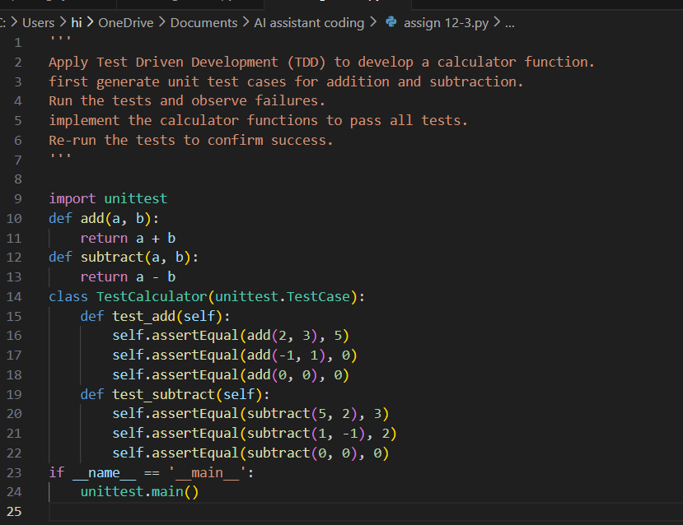

Output:
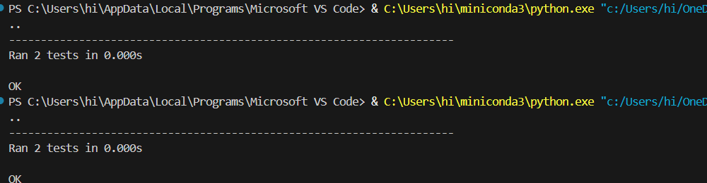
Explanation:
Test Driven Development ensures that test cases are written before implementing the actual functionality. It helps verify that the program meets requirements and reduces bugs during development. Using AI tools like Copilot speeds up writing tests and implementation while maintaining code correctness.

Task Description -4 (Data Structures – Queue Implementation with
AI Assistance)
➢ Task:
Use AI assistance to generate a Python program that implements
a Queue data structure.
Instructions:
➢ Prompt AI to create a Queue class with the following methods:
• enqueue(element)
• dequeue()
• front()
• is_empty()
➢ Handle queue overflow and underflow conditions.
➢ Include appropriate docstrings for all methods.

Prompt:
generate a Python program that implements a Queue data structure.
create a Queue class with enqueue(element), dequeue(), front() and is_empty() methods.
Handle queue overflow and underflow conditions.
Include appropriate docstrings for all methods.
take user input

Code:
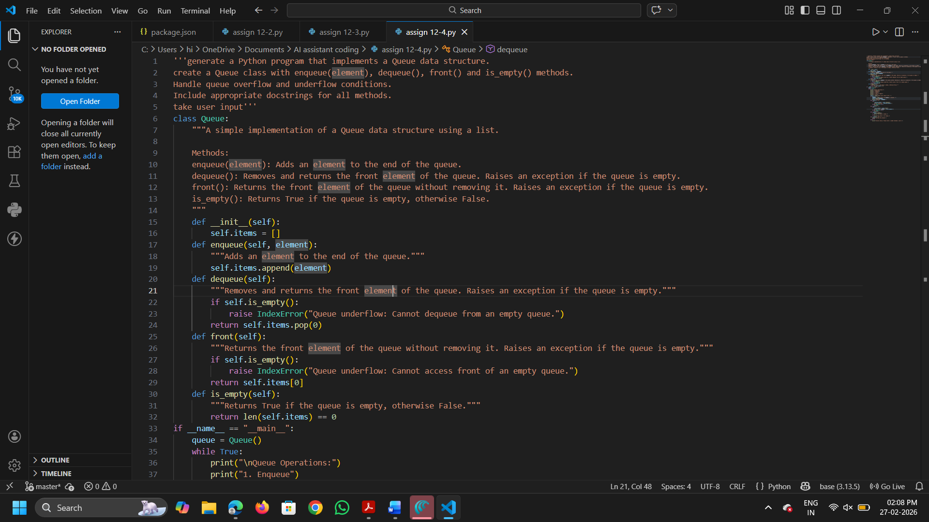
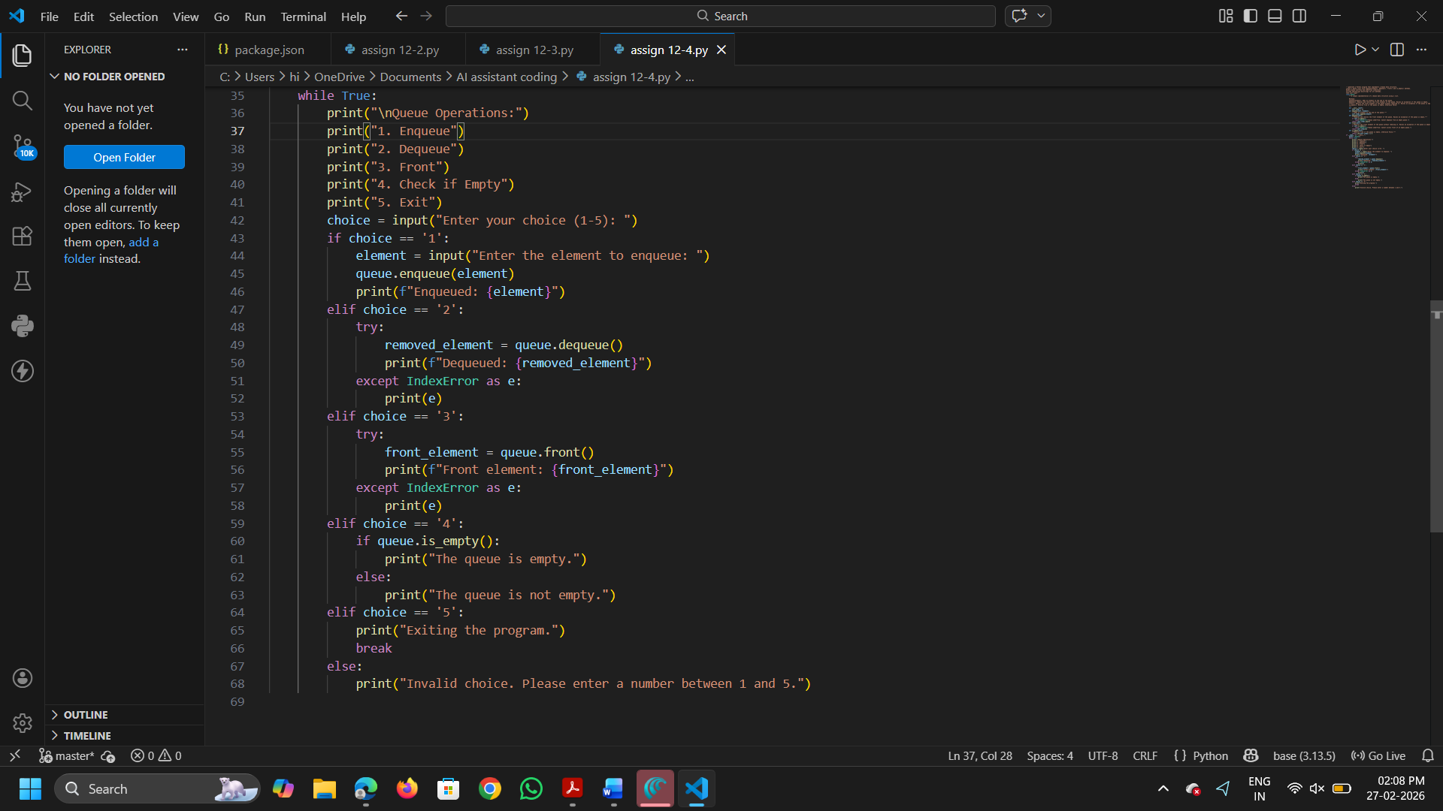
Output:
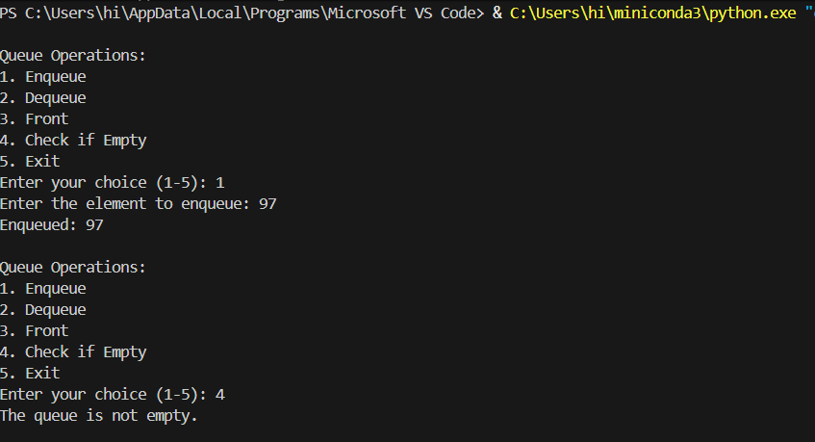
Explanation:
Queue is suitable because it follows the FIFO (First In First Out) principle, which is ideal for processing elements in the order they arrive. It is commonly used in task scheduling, buffering, and request handling systems. Other data structures like Stack (LIFO) or Linked List do not naturally maintain FIFO order for processing elements.

Task Description -5 (Algorithms – Bubble Sort vs Selection Sort)
➢ Task:
Use AI to implement Bubble Sort and Selection Sort algorithms
and compare their behavior.
Instructions:
➢ Prompt AI to generate:
• bubble_sort(arr)
• selection_sort(arr)
➢ Include comments explaining each step.
➢ Add docstrings mentioning time and space complexity.

Prompt:
implement Bubble Sort and Selection Sort algorithms and compare their behavior.
generate bubble_sort(arr) and selection_sort(arr)
Include comments explaining each step.
Add docstrings mentioning time and space complexity.

Code:
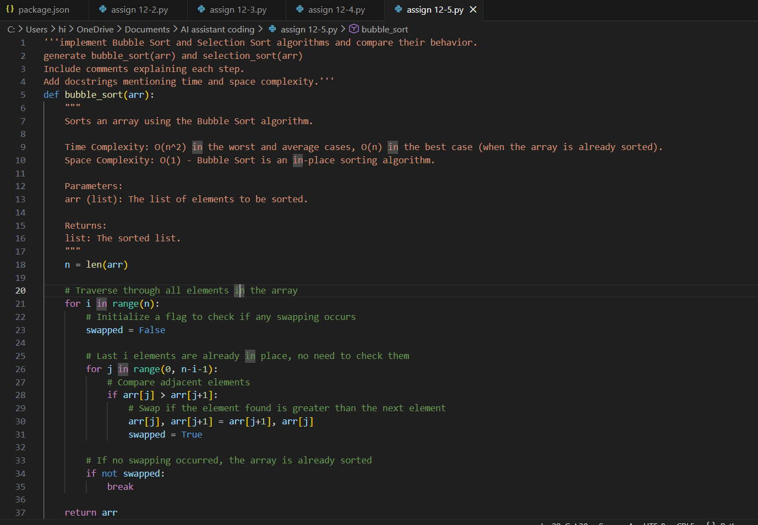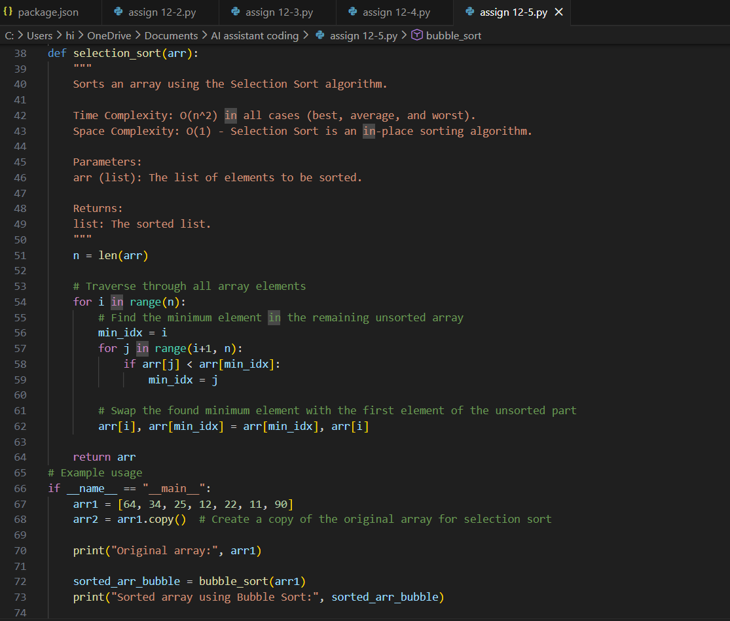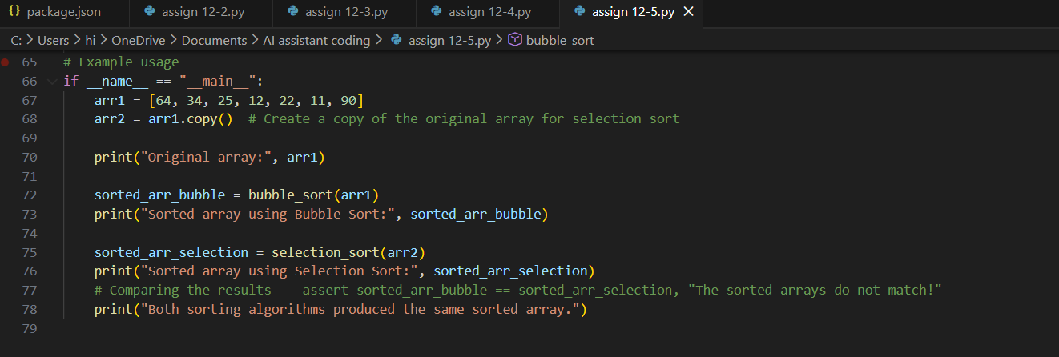
Output:
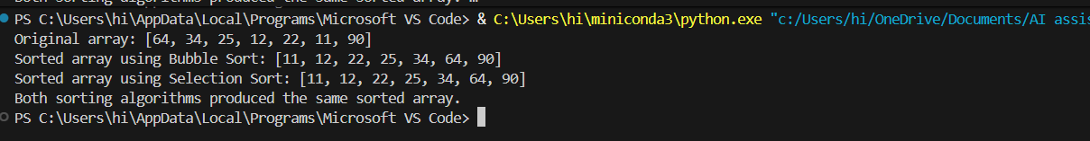

Explanation:
Sorting algorithms like Bubble Sort and Selection Sort require indexed access, which is efficiently supported by arrays (Python lists). Arrays allow easy swapping of elements using indices, which is essential for these algorithms. Other data structures like linked lists, stacks, or queues are inefficient for direct element comparison and swapping, making arrays the most suitable choice.

